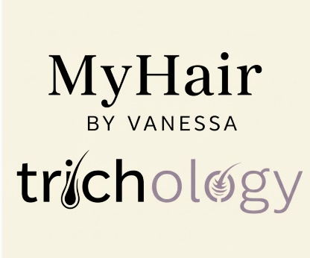
MyHair By Vanessa Product Policy – Terms and Conditions

Wig Refunds, Returns and Warranty Policy

Cutomised Wigs
Under the Consumer Rights Act 2015, bespoke or personalised items are exempt from the 14 day “change of mind” right to cancel. All wigs that have been worn, cut, styled, coloured, thinned or altered in anyway are considered bespoke items and are therefore non-refundable. Once a wig has been personalised it cannot be resold
Customisation includes but is not limited to:
- Cutting or reshaping
- Colour adjustments
- Styling
- Thinning or density changes

Change of Mind
MyHair By Vanessa does NOT offer refunds or exchange for:
- Change of mind
- Dissatisfaction after leaving the salon
- Claims relating to cut or style that were agreed during consultation
Clients are encouraged to take time during the consultation process to ensure they are happy before any work is carried out.

Faulty Wigs
The seller accepts no responsibility for goods returned faulty unless such goods can be fairly deemed to have become faulty due to any manufactured defect within the first three months of wear.
The manufacturer reserves the right to investigate your complaint and inspect the item for testing by an experienced technician. If this is to be carried out by the manufacturer their response will be required before any actions can be taken.
Hairpieces and wigs damaged due to customer abuse or neglect cannot under any circumstances be accepted for credit or replacement by the seller.
The buyer must ensure that any items returned for inspection are washed prior to returning, we reserve the right to reject any items or complaint if this has not been adhered to.
If we find a manufacturing fault with an item, we reserve the right to repair it.
If a manufacturing fault is not found:
- the item will be sent back to you which may be at your cost.
- Under certain circumstances we may offer you, at our discretion, to repair the item at your cost.
All expressed or implied conditions of warranties, statutory or otherwise, not expressly included in these Conditions of sale are excluded.
We will not be held responsible for any injury or damages incurred by users of the products we sell. The buyer is responsible for completing a sample test of any products purchased for use at home that are applied to their hair/skin/scalp including but not limited to wigs/hairpieces, any hair/scalp/wig/hairpiece cleaning/maintenance products such as shampoos, conditioners, protective sprays/creams/ointments/treatments/oils, sanitising products, styling products such as gels/hair or finishing sprays/creams/putties/wax, adhesives, tapes, make-up products etc.
We will not be held responsible for any goods or services supplied to you by a third-party supplier.

